Week 4 Project LAB

Aubrey D. Soule
IT, Software Development and Coding, ECPI University
SDC330: Advanced Programming Using Java
Dr. Helio Castro
May 3, 2026

Screenshots of code running and using every menu number

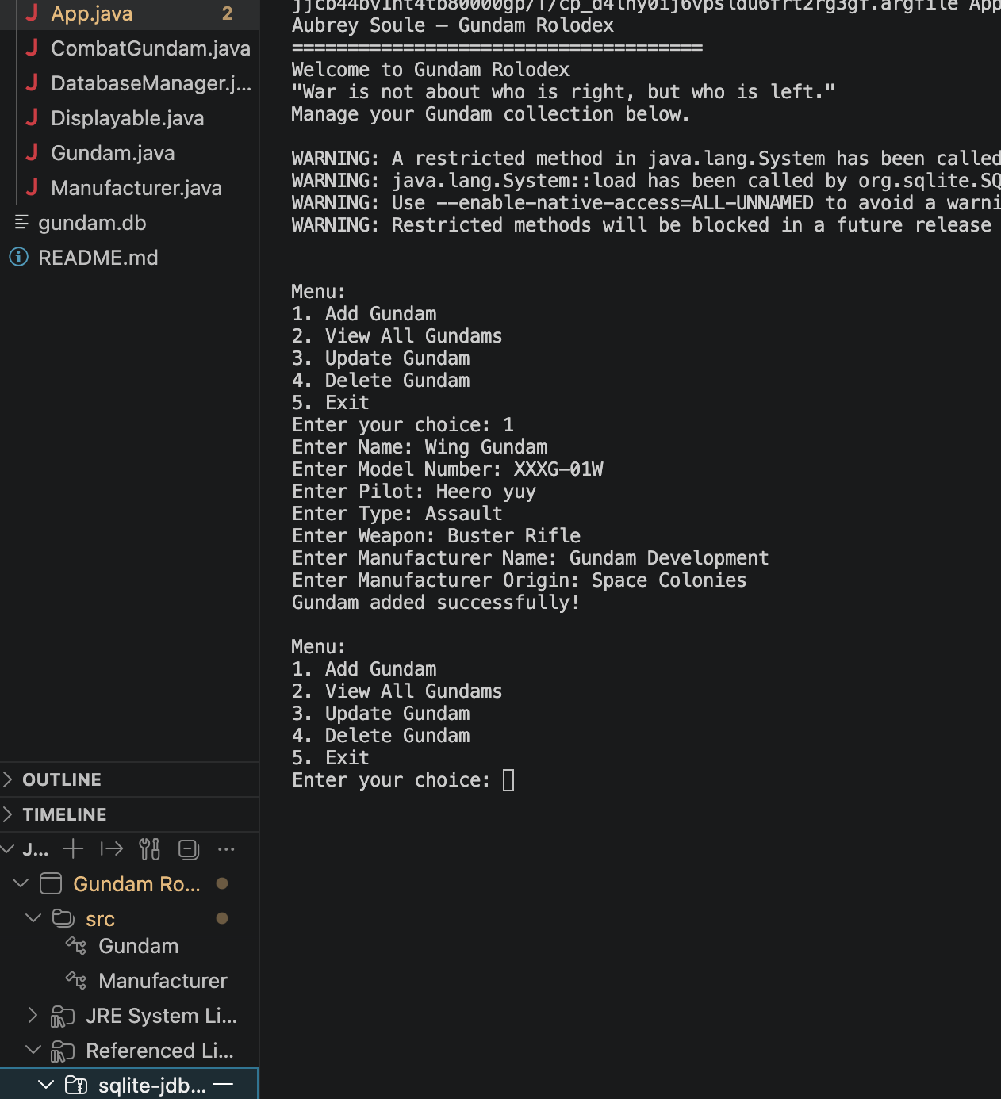
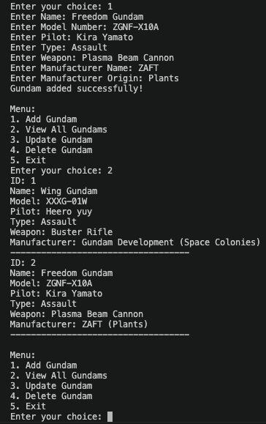
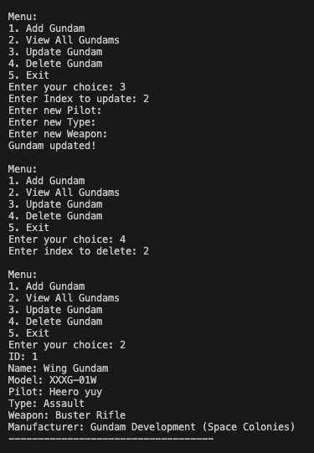
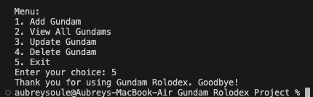
References

